**Enclosure to DepEd Order No. 014, s. 2018**

IMPLEMENTING GUIDELINES ON THE ADMINISTRATION OF THE REVISED PHILIPPINE INFORMAL READING INVENTORY (PHIL-IRI)

I. Rationale

1. Literacy is one of the most fundamental skills a child can learn. Reading is the foundation for all academic learning. Learning to read, write and count is crucial to a child’s success in school and in later life. Literacy improvement is one of the priorities of the Department of Education (DepEd). It is anchored on the flagship program of the Department: “Every Child A Reader Program,” which aims to make every Filipino child a reader and a writer at his/her grade level.

2. The Philippine Informal Reading Inventory (Phil-IRI) Assessment Tool is aimed to be used as a classroom-based assessment tool to measure and describe students’ reading performance. Information gathered from the assessment can help classroom teachers design and provide appropriate reading instruction for their students. This diagnostic approach to describing how children read embraces inclusionary principles that emphasize the need for education that is learner-oriented, responsive and culturally sensitive. At the school level, the information from Phil-IRI assessment will help school heads plan for appropriate school reading programs or activities for improved student learning outcomes.

3. Informal reading inventories are designed to provide greater insight into an individual learner’s reading level vis-a-vis a specific passage in order to allow teachers to customize instruction to the needs of their students (Rutlledge, 1998). The underlying assumption is that an approximation of a student’s literacy abilities is best shown through his/her performance in actual reading and writing tasks. This is in contrast to formal reading tests that are standardized and often conducted for the purpose of comparing a student’s performance with that of others (Weaver, 2014).

II. Scope of the Policy

4. This DepEd Order provides the guidelines for the administration of the revised Philippine Informal Reading Inventory (Phil-IRI). The tool is administered for Grades 3 to 6 learners in public elementary schools nationwide. It defines the responsibilities of the different levels of governance pertaining to the dissemination and utilization of the said tool.

III. Definition of Terms

5. For the purposes of this Order, the following terms are defined and understood as follows:

a. Phil-IRI refers to the revised assessment tool composed of a set of graded passages administered to the whole class and to individual students, which was designed to determine a student’s reading level.

b. Phil-IRI Group Screening Test (GST) is a 20-item group-administered reading comprehension test for each grade level covering Grade 3 to Grade 6 in Filipino and Grade 4 to Grade 6 in English. The objective of the GST is to identify students who need further testing.

c. Phil-IRI Graded Passages refer to informal assessment tools used to record individual student’s performance in oral reading, silent reading and listening comprehension. There are four sets (Sets A, B, C and D) of passages for both Filipino and English spanning Kindergarten to Grade 7 levels which can be used for both pretesting and post-testing.

• The Phil-IRI Oral Reading Test is administered in order to:

– identify the student’s miscues in oral reading;

– record the number of words that a student reads per minute; and

– find out how well a student understands the passage read

• The Phil-IRI Listening Comprehension is administered when the student is identified as a nonreader. The purpose is to find out how well a student understands the selection which will be read by the test administrator/teacher. Then the test administrator reads the multiple choice questions and the student answers them orally.

MORE FROM TEACHERPH

[DEPED ORDER](https://www.teacherph.com/category/issuances/deped-order/)

[Early Language Literacy and Numeracy Program Funds](https://www.teacherph.com/early-language-literacy-and-numeracy-program-funds/)

May 23, 2018

[DEPED ORDER](https://www.teacherph.com/category/issuances/deped-order/)

[Promotion and Compensation of all ALS Implementers](https://www.teacherph.com/promotion-compensation-als-implementers/)

May 18, 2018

[DEPED ORDER](https://www.teacherph.com/category/issuances/deped-order/)

[DepEd School Calendar for School Year 2018-2019](https://www.teacherph.com/deped-school-calendar-2018-2019/)

May 16, 2018

[DEPED ORDER](https://www.teacherph.com/category/issuances/deped-order/)

[Flexible Working Hours of DepEd Non-Teaching Personnel](https://www.teacherph.com/deped-non-teaching-personnel-working-hours/)

May 11, 2018

• The Phil-IRI Silent Reading Test maybe administered after the Oral Reading Test is conducted to further check the student’s comprehension skill.

d. Phil-IRI Testing Kit is a set of materials composed of a) the Manual of Administration, b) Group Screening Test for English and Filipino, c) Graded Passages with Comprehension Questions for English and Filipino, and d) Phil-IRI forms.

IV. Policy Statement

6. These guidelines establish the standardized procedures on administering the Phil-IRI as described in this DepEd Order. This procedure, when applied and strictly followed, should ensure that:

a. teachers and school heads can adopt an evidence-based approach to classroom instruction;

b. literacy instruction is learner-oriented and responsive to the strengths and needs of individual students and/or whole class; and

c. it supports DepEd Order No. 8, s 2015 “Policy Guidelines on Classroom Assessment for the Ktol2 Basic Education Program”.

V. Procedure of Administration

7. The Bureau of Learning Resources (BLR) is responsible for uploading the Phil-IRI materials thru the Learning Resource Management Development System (LRMDS) portal of the DepEd website before the start of the school year in time for the opening of classes. These can be downloaded by the teachers, school heads and education supervisors. To ensure that teachers have the complete set of materials, the schools are advised to use the MOOE funds for the reproduction and distribution. It is necessary that the region/division shall conduct an orientation-training to teachers on the proper administration of the revised Phil-IRI which shall be part of the Early Language Literacy and Numeracy (ELLN) Program of the Department of Education.

8. All students will undergo the Phil-IRI Group Screening Test (GST) in Filipino, and/or English. Students identified to be performing below level of expectation (those with a total Raw Score below 14 in the Phil-IRI GST) should undergo further assessment through the individually administered Phil-IRI Graded Passages.

9. Table 1 shows the schedule of activities in relation to the administration of the Phil-IRI.

**Table 1. Schedule of Activities**

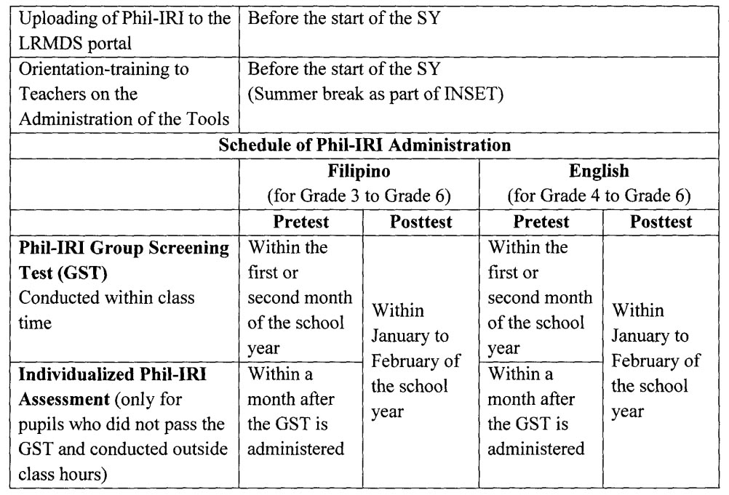

VI. Roles and Responsibilities

10. For the standard and efficient implementation of the Phil-IRI, Table 2 shows the roles and responsibilities of the different levels of governance.

**Table 2. Roles and Responsibilities**

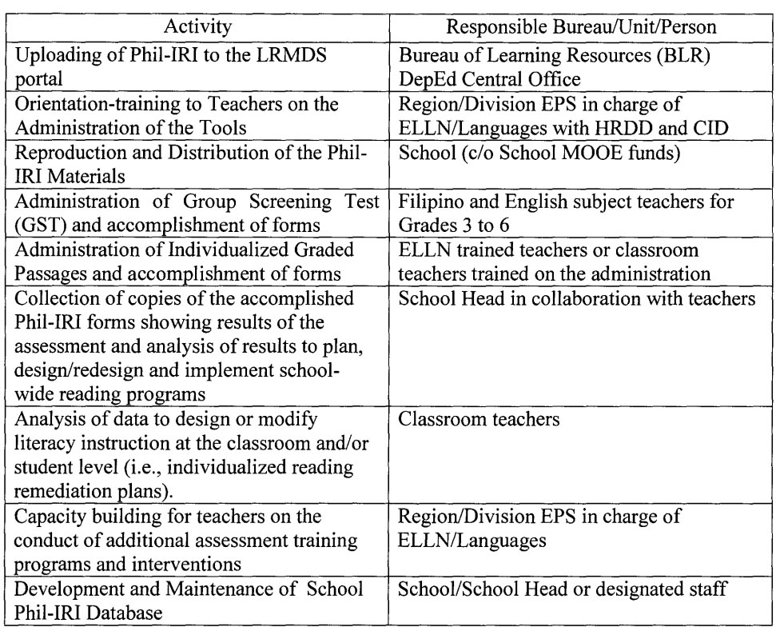

11. The teachers who will administer the Phil-IRI should read the manual thoroughly and prepare all the necessary materials and forms prior to the scheduled date of test administration. The details on the mechanics of the administration, which include directions for administering, scoring and interpreting data, are contained in the manual of administration. The Handbook for Reading Intervention as part of the Phil-IRI material or other appropriate reading activities can be used as guide or reference for interventions.

12. The schools/school heads shall ensure that a school database of Phil-IRI results will be developed and maintained. This will provide historical data for the school as they analyze the trends and develop more appropriate interventions for our learners.

VII. Monitoring and Evaluation

13. To ensure the effective implementation of the policy, Table 3 shows the roles and responsibilities of the different levels of governance in monitoring the administration of Phil-IRI.

**Table 3: Roles and Responsibilities in M & E**

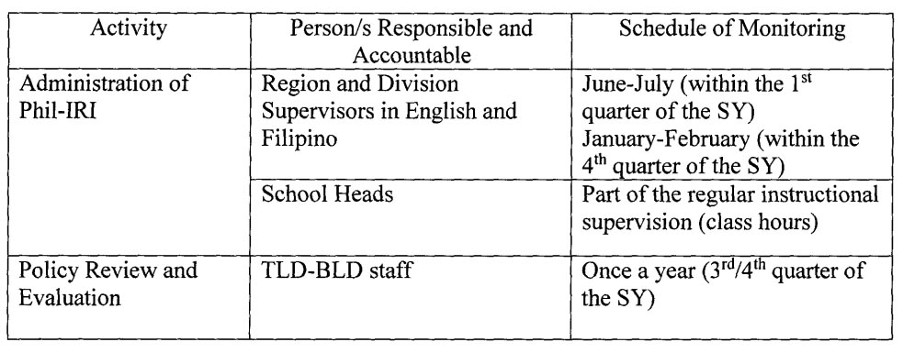

VIII. References

Rutledge, S. (1998). Informal Reading Inventory. Retrieved from http://lrs.ed.uiuc.edu/students/srutledg/iri.html

Weaver, B. (2014). Formal vs Informal Assessments. Retrieved from http://lrs.ed.uiuc.edu/students/srutledg/iri.html

DepEd Order No. 8, s 2015 “Policy Guidelines on Classroom Assessment for the Ktol2 Basic Education Program”.

IX. Effectivity

14. All existing Orders and Memoranda inconsistent with this Order are rescinded. These guidelines will remain in force and effect, unless sooner, repealed, amended or rescinded.

15. Immediate dissemination of and strict compliance with this Order is directed.